Experiment

**Premise**

* Subjects will lay in the fMRI scanner and drink either appetitive or neutral juice. They will be cued before juice consumption about the probability of receiving the appetitive juice. Sometimes the outcome will be ignored and the subject will receive no juice.

**Player**

* Just lays there and drinks.

**Environment**

* A PsychoPy experiment in the scanner. A tube will run from juice press to subject’s mouth.

**Experiment**

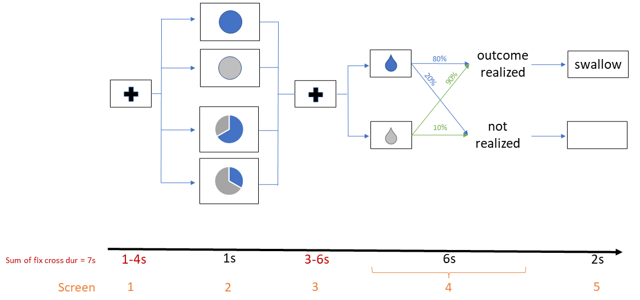

Pre-Experiment

* Appetitive juice is selected prior to experiment by liking rating task (0 to 5). Neutral juice is a saline solution made of the ionic components of saliva.
* Instructional period with 10 practice trials on laptop, no juice.

Screen 1

* Subjects fixate on a fixation cross for 1-4s, jittered according to a pre-determined trial duration.

Screen 2

* A pie chart is presented with the probability of appetitive (blue) vs neutral (grey) juice for 1 s.

Screen 3

* A fixation cross is presented for 3-6 s, jittered according to a pre-determined trial duration.

Screen 4

* The screen will present a water drop stimulus (blue: appetitive; grey: neutral) for 6 s.
* If outcome is appetitive, then inject juice with 80% probability and ignore with 20% probability.
* If outcome is neutral, then inject juice with 90% probability and ignore with 10% probability.

Screen 5

* If juice was injected, the screen will display instructions to swallow for 2 s.
* If no juice was injected, the screen will be blank for 2 s.

**Trial Structure**

There are 4 conditions:

1. Certain appetitive (30 trials)
2. Certain neutral (30)
3. Likely appetitive (50)
4. Unlikely appetitive (50)

Subjects are not told the underlying probability of realizing the outcome: 80% for appetitive outcomes, 90% for neutral outcomes.

Total of 160 trials, split into 4 blocks of 40 trials. Conditions are randomly ordered and distributed across the 4 blocks.

Trials in which the outcome is not realized are spaced out such that there are at least two realized trials between each instance of non-realization.

Each trial is 16 s. There are two fixation cross screens per trial, summing up to a total duration of 7 s.

Each block is 10 m 40 s. Total task time is 42 m 40 s.

I estimate roughly 10 minutes for appetitive juice selection, 15 minutes of instruction period before the experiment, and 15 minutes of cumulative break time between blocks.

This totals 40 minutes of non-task time, for a total 1 h 22 m 40 s of scanner time per subject.

I can book the scanner room for one, 2 h session per subject. I plan to pay subjects a $60 show-up fee (2 h * $30 per hour).

**Analysis**

*Why these 4 conditions?*

The certainly appetitive and aversive conditions (1,2) give us baseline levels of OFC activity to compare uncertain trials to.

Likely and unlikely appetitive (3,4) give us low and high surprise utility trials. Comparing these trials, along with the certain trials, gives us tests of KR preferences.

*Why have an underlying probability of realizing the outcome?*

Per subject, on average, 72 out of 80 neutral trials and 64 out of 80 appetitive trials will have a realized outcome. This leaves 8 and 16 trials that will not have a realized outcome. We can use these 16 appetitive trials to look for evidence of RPE without consumption in the OFC.

When looking for this RPE signal, I propose that we combine all trials where the displayed outcome is appetitive (regardless of the probability). In the appetitive, non-realized case, RPE should be negative during screen 4 since the outcome is displayed and reward is withheld. The fact that we combine over all probabilities is fine, since we’re looking for any significant change in signal, and this aggregation only serves to bias our significance away from 0. So if we find no significance even in the presence of this bias, then we can comfortably say that our consumption utility signal is not an RPE.

*Why is the probability of outcome realization different for appetitive and neutral outcomes?*

Since the neutral liquid is… well… neutral, it may be difficult to tell whether we are looking at an RPE = 0, or no RPE at all. Therefore, we don’t need to apply this probability of realization to the neutral juices for our analysis. We include it anyways so subjects don’t learn to completely expect neutral outcomes to be realized, in the same way that they can’t completely expect appetitive outcomes to be realized.

**Recording** **data**

* Generate a file that keeps track of:
  + Subject ID
  + Session
  + Block
  + Trial
  + Trial onset (using a timer that starts at the beginning of the block)
  + ITI duration
  + Pie chart 1 duration
  + Fixation cross (to signal incoming juice/no juice screen) duration
  + Probability in first pie chart
  + Outcome
  + Juice screen duration
  + Swallow screen duration
  + Whole brain BOLD activity (which I believe will record one long dataset for each block)

**Interfacing with other hardware**

* PsychoPy needs to interface with juice pumps and the fMRI scanner.
  + Scanner sends input “5” when it starts scanning. Use this to begin experiment. And implement lots of experimenter-controlled checks/stops.
  + Not sure how juice pumps work yet.